Exercise 3: Stored Procedures

Scenario 1: The bank needs to process monthly interest for all savings accounts.
Question: Write a stored procedure ProcessMonthlyInterest that calculates and updates the balance of all savings accounts by applying an interest rate of 1% to the current balance.

CREATE OR REPLACE PROCEDURE ProcessMonthlyInterest IS
CURSOR savings_accounts IS
SELECT AccountID, Balance FROM Accounts WHERE AccountType = 'Savings' FOR UPDATE;

v_new_balance NUMBER;
BEGIN
FOR acc IN savings_accounts LOOP
v_new_balance := acc.Balance + (acc.Balance * 0.01);

UPDATE Accounts
SET Balance = v_new_balance,
LastModified = SYSDATE
WHERE AccountID = acc.AccountID;

DBMS_OUTPUT.PUT_LINE('Interest applied: AccountID=' || acc.AccountID ||
', Old Balance=' || acc.Balance ||
', New Balance=' || v_new_balance);
END LOOP;

COMMIT;

EXCEPTION
WHEN OTHERS THEN
ROLLBACK;
DBMS_OUTPUT.PUT_LINE('Error processing interest: ' || SQLERRM);
END;
/
OUTPUT:
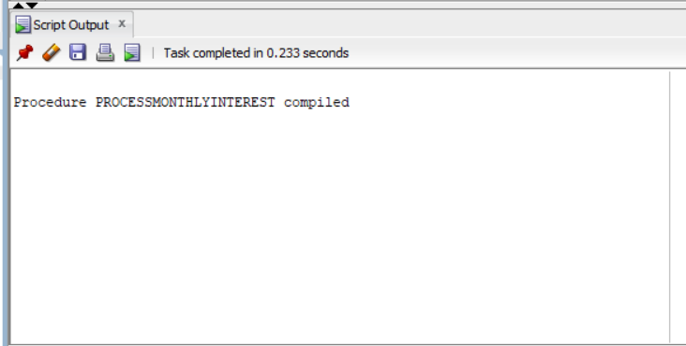

Scenario 2: The bank wants to implement a bonus scheme for employees based on their performance.
Question: Write a stored procedure UpdateEmployeeBonus that updates the salary of employees in a given department by adding a bonus percentage passed as a parameter.

CREATE OR REPLACE PROCEDURE UpdateEmployeeBonus(
p_Department IN VARCHAR2,
p_BonusPercent IN NUMBER
) AS
CURSOR emp_cursor IS
SELECT EmployeeID, Name, Salary FROM Employees WHERE Department = p_Department FOR UPDATE;

v_new_salary NUMBER;
BEGIN
FOR emp IN emp_cursor LOOP
v_new_salary := emp.Salary + (emp.Salary * p_BonusPercent / 100);

UPDATE Employees
SET Salary = v_new_salary
WHERE EmployeeID = emp.EmployeeID;

DBMS_OUTPUT.PUT_LINE('Bonus applied: EmployeeID=' || emp.EmployeeID ||
', Name=' || emp.Name ||
', Old Salary=' || emp.Salary ||
', New Salary=' || v_new_salary);
END LOOP;

IF emp_cursor%ROWCOUNT = 0 THEN
DBMS_OUTPUT.PUT_LINE('No employees found in department: ' || p_Department);
END IF;

COMMIT;

EXCEPTION
WHEN OTHERS THEN
ROLLBACK;
DBMS_OUTPUT.PUT_LINE('Error updating bonuses: ' || SQLERRM);
END;
/

OUTPUT:

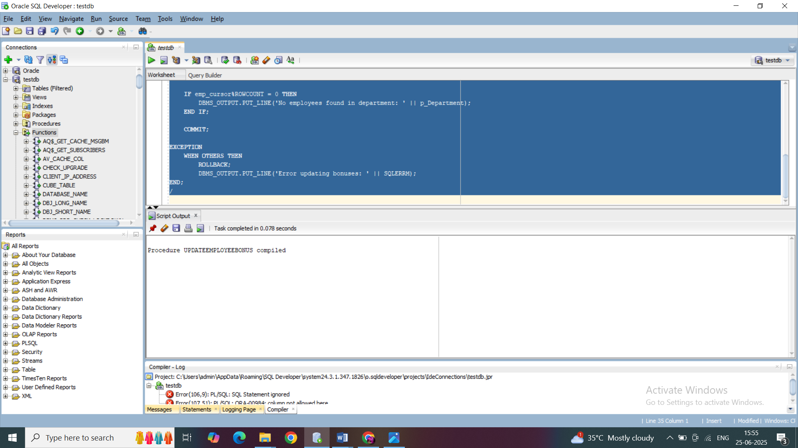

Scenario 3: Customers should be able to transfer funds between their accounts.
Question: Write a stored procedure TransferFunds that transfers a specified amount from one account to another, checking that the source account has sufficient balance before making the transfer.

CREATE OR REPLACE PROCEDURE TransferFunds(
p_SourceAccountID IN NUMBER,
p_TargetAccountID IN NUMBER,
p_Amount IN NUMBER
) AS
v_SourceBalance NUMBER;
v_TargetBalance NUMBER;
BEGIN
-- Lock and get source balance
SELECT Balance INTO v_SourceBalance FROM Accounts
WHERE AccountID = p_SourceAccountID FOR UPDATE;

IF v_SourceBalance < p_Amount THEN
RAISE_APPLICATION_ERROR(-20001, 'Insufficient balance in source account.');
END IF;

-- Lock and get target balance
SELECT Balance INTO v_TargetBalance FROM Accounts
WHERE AccountID = p_TargetAccountID FOR UPDATE;

-- Update source
UPDATE Accounts
SET Balance = v_SourceBalance - p_Amount,
LastModified = SYSDATE
WHERE AccountID = p_SourceAccountID;

-- Update target
UPDATE Accounts
SET Balance = v_TargetBalance + p_Amount,
LastModified = SYSDATE
WHERE AccountID = p_TargetAccountID;

-- Transactions
INSERT INTO Transactions (TransactionID, AccountID, TransactionDate, Amount, TransactionType)
VALUES (Transactions_SEQ.NEXTVAL, p_SourceAccountID, SYSDATE, p_Amount, 'TransferOut');

INSERT INTO Transactions (TransactionID, AccountID, TransactionDate, Amount, TransactionType)
VALUES (Transactions_SEQ.NEXTVAL, p_TargetAccountID, SYSDATE, p_Amount, 'TransferIn');

DBMS_OUTPUT.PUT_LINE('Transfer Successful!');
DBMS_OUTPUT.PUT_LINE('From Account: ' || p_SourceAccountID || ', Deducted: ' || p_Amount ||
', New Balance: ' || (v_SourceBalance - p_Amount));
DBMS_OUTPUT.PUT_LINE('To Account: ' || p_TargetAccountID || ', Added: ' || p_Amount ||
', New Balance: ' || (v_TargetBalance + p_Amount));

COMMIT;

EXCEPTION
WHEN NO_DATA_FOUND THEN
ROLLBACK;
DBMS_OUTPUT.PUT_LINE('Invalid source or target account ID.');
WHEN OTHERS THEN
ROLLBACK;
DBMS_OUTPUT.PUT_LINE('Error during fund transfer: ' || SQLERRM);
END;
/

OUTPUT:
